Type script

==>what is type script ?

ans : type script is super set of javascript ( means it will going to contain the exiting feature of javascript along with that it will going to contain some extra feature )

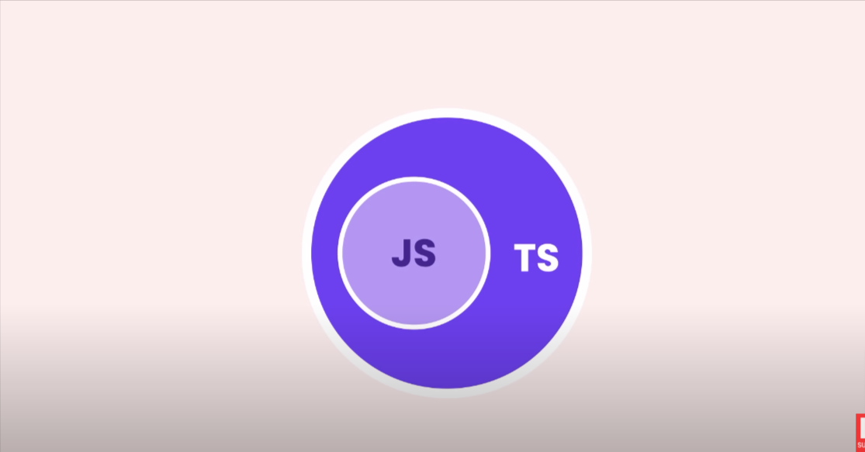

Benifit of type script :

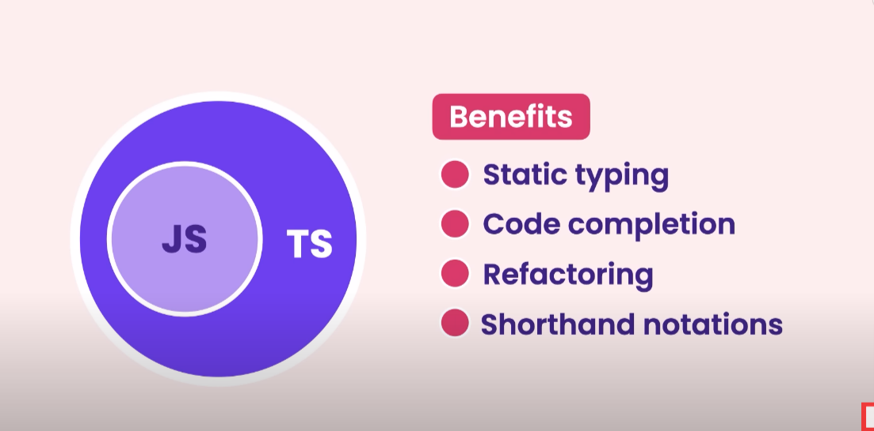

* static typing

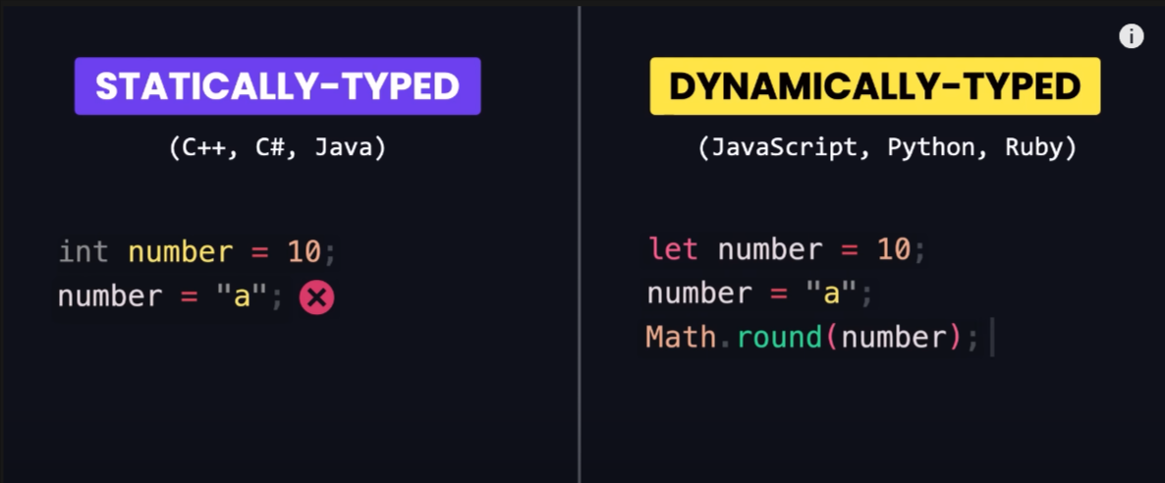

in statically type : we provide the datatypes of variable at the run time

in dynamic type : we do not provide the data type of varible at the run time

note :

i ) since the javascript is a dynamically type

d programming so typescript is solved this problem .

drwaback of type script :

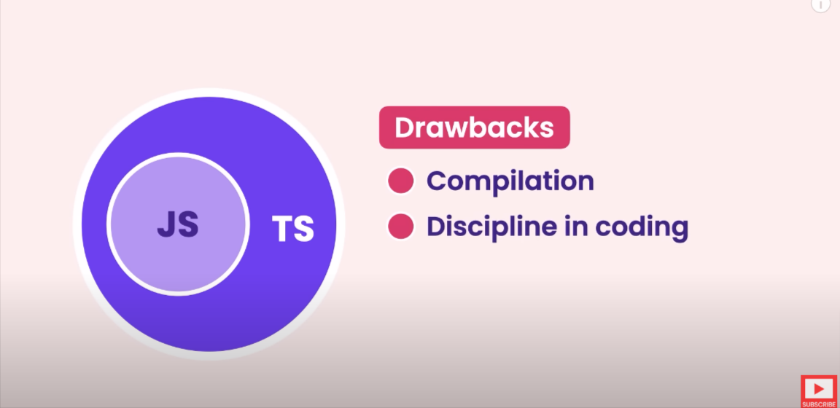

compilation :

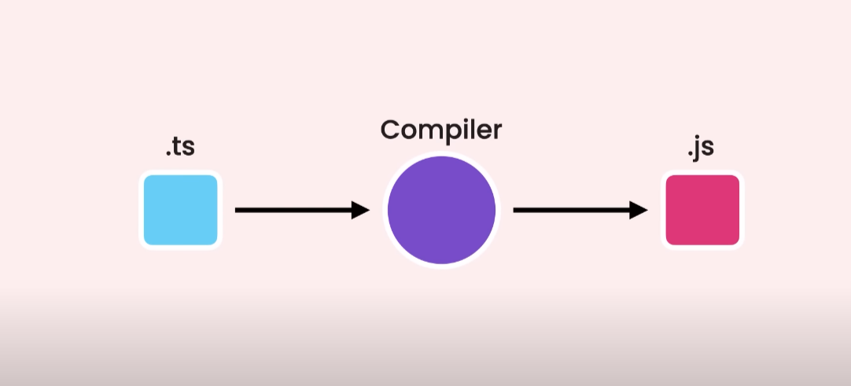

installation :

step 1 : install type script module golbally : npm i -g typescript

step 4 : to know wether the type script is inatalled or not we can run ( tsc -v )

* creating config for the typescript

step 1 : tsc --init

it will going to create a tsconfig.json file

that fill contain all the feature of typescript in commented manner

step 2 : in tsconfig file we will haveing module at middle bottom part in that we have rootDir which is commented we need to uncomment it and put the name of our source file

ex : src folder i have creted in that i have my index.ts file

*"rootDir"*: "./src",

step 3 : in emmit we have to uncomment outdir and put the name of our distnation folder

*"outDir"*: "./dist",

step 4 : in emmit we have to uncomment removecomment :=> it will going to remove all the comment we have done in our typescript file while compiling

*"removeComments"*: true,

step 5 : in emmit uncomment noemmiterror => because by default if i have some error in typescript file it still going to genrate js file code to remove this we need to uncomment this

*"noEmitOnError"*: true,

step 6 : to compile just run

tsc // in terminal

* debugging type script

step 1 : in emmit we have to uncomment : source map

step 2 : run : tsc // in terminal

it will going to create file with the extension ( .js.map)

step 3 : config json for debugging

{

    // Use IntelliSense to learn about possible attributes.

    // Hover to view descriptions of existing attributes.

    // For more information, visit: https://go.microsoft.com/fwlink/?linkid=830387

*"version"*: "0.2.0",

*"configurations"*: [

        {

*"type"*: "node",

*"request"*: "launch",

*"name"*: "Launch Program",

*"skipFiles"*: [

                "<node_internals>/**"

            ],

*"program"*: "${workspaceFolder}\\dist\\index.js",

*"preLaunchTask"*: "tsc: build - tsconfig.json",

*"outFiles"*: [

                "${workspaceFolder}/**/*.js"

            ]

        }

    ]

}

